**SOFTWARE ENGINEERING**

**CLASS PRACTICALS**

1.Online voting system

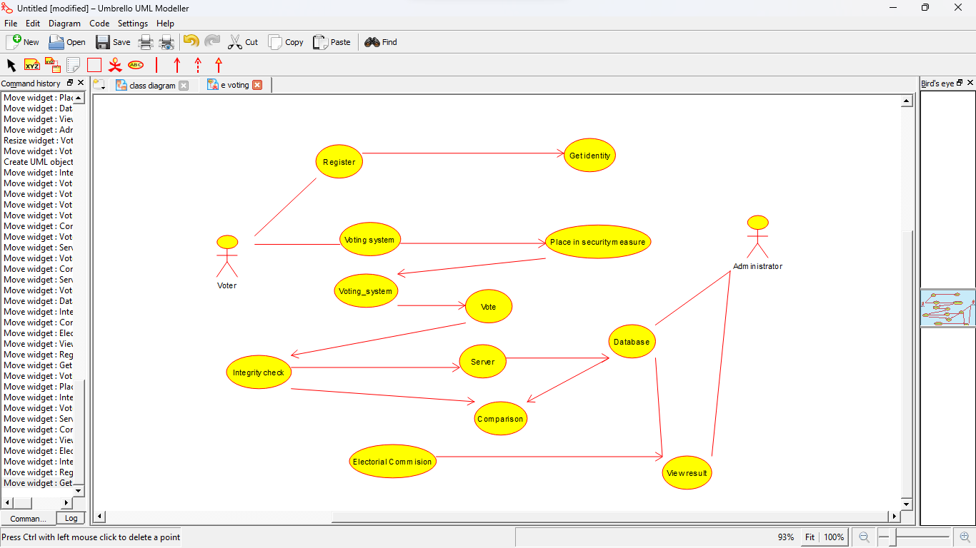

2.Library management system

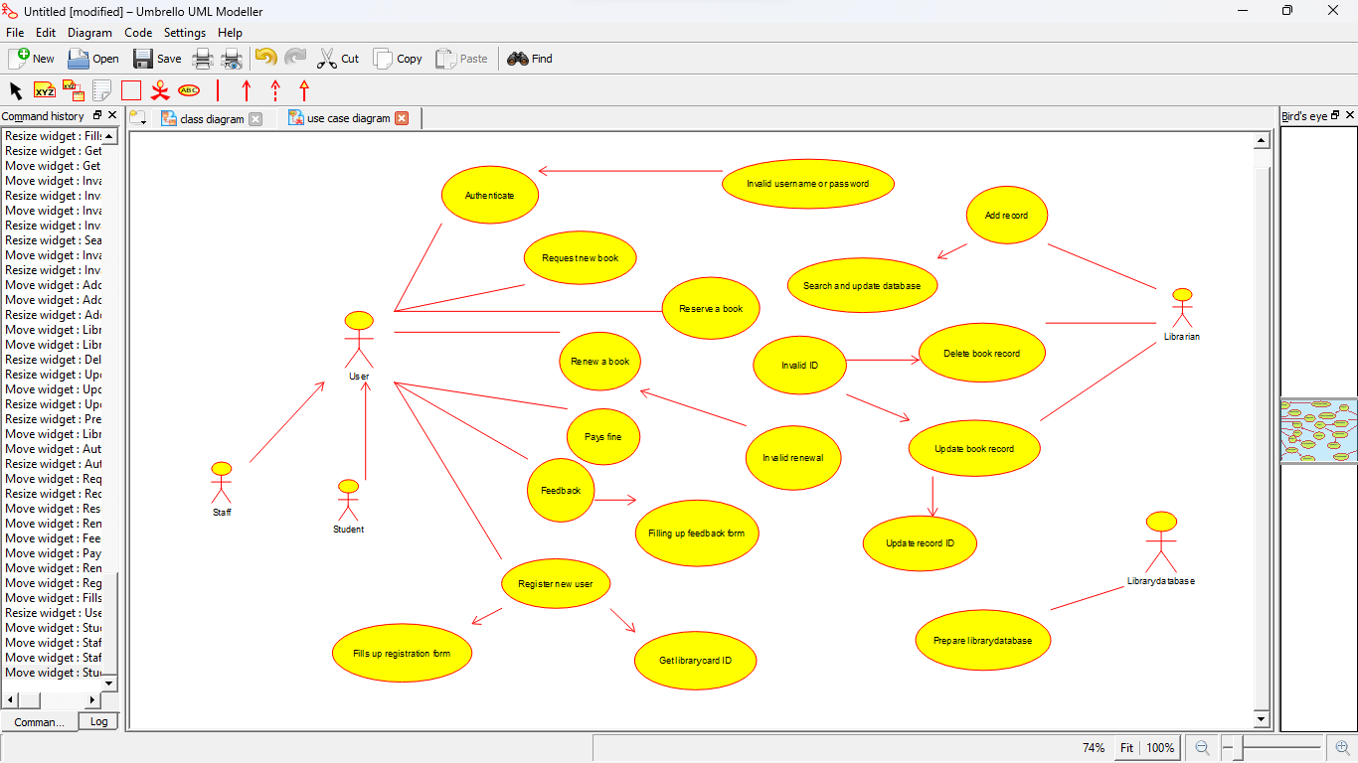

3.Railway reservation system

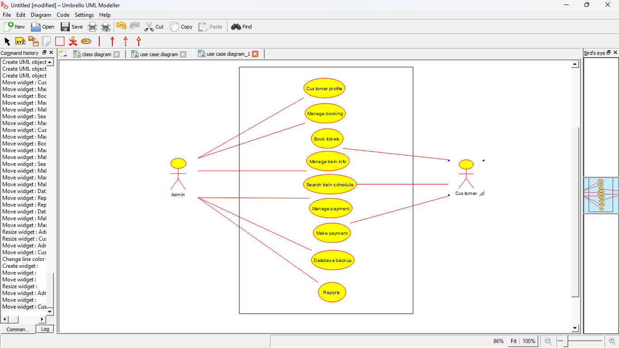

4.Hospital management system

